Smart Lecture Slot Utilization and Classroom Efficiency Analysis
(S.I.W.S. N.R. Swamy College of Commerce & Economics (Autonomous))

A Project Report
Submitted in partial fulfilment of the requirements
for the award of the Degree of
BACHELOR OF SCIENCE (DATA SCIENCE)
SEMESTER III
By
Shreya Surve
Roll Number:
25315A0007

Under the esteemed guidance of
Mrs. Pooja Soni

Assistant Professor,

Department of Computing



DEPARTMENT OF COMPUTING
VIDYALANKAR SCHOOL OF INFORMATION TECHNOLOGY
(Autonomous College, Affiliated to the University of Mumbai)
MUMBAI, 400037
MAHARASHTRA
2026 - 2027

VIDYALANKAR SCHOOL OF INFORMATION TECHNOLOGY
(Autonomous College, Affiliated to the University of Mumbai)
MUMBAI-MAHARASHTRA-400037

DEPARTMENT OF COMPUTING

CERTIFICATE
I hereby certify that Ms. Shreya Surve (Roll Number: 25315A0007), Student of Vidyalankar School of Information Technology, studying in S.Y. B.Sc. in Data Science Semester III, has completed a field project titled “Smart Lecture Slot Utilization and Classroom Efficiency Analysis” in the area of “Education Technology” specialization for the academic year 2026-27. To the best of my knowledge, the work of the student is original and the information included in the project is correct.

Internal Guide |  | Programme Co-ordinator
Internal Examiner |  | External Examiner
Date: | College Seal |  | Principal

DECLARATION
I, Ms. Shreya Surve Student of Vidyalankar School of Information Technology, studying in S.Y. B.Sc. in Data Science, hereby declare that I have completed the field project entitled “Smart Lecture Slot Utilization and Classroom Efficiency Analysis” during the academic year 2026-27.
The report work is original and the information/data included in the report is true from the primary and/ secondary data gathered and analyzed as part of this project.
Due credit is extended on the work of Literature/Secondary Survey by endorsing it in the Bibliography as per prescribed format.

Signature of the Student with Date

Name of Student

ACKNOWLEDGEMENT
We express our sincere gratitude to the University of Mumbai and Vidyalankar School of Information Technology for providing us an opportunity to undertake this Field Project, which provided us with this valuable opportunity to enhance our practical learning.
We extend our heartfelt thanks to S.I.W.S. N.R. Swamy College of Commerce & Economics and Smt. Thirumalai College of Science (Autonomous) for granting us the opportunity to visit and work on this project. We are especially grateful to our External Guide: Swaraj Dinkar Humbare for their valuable guidance, support, encouragement, and constructive feedback throughout the project. The support and cooperation received from the staff members provided us with meaningful exposure and helped us connect our academic knowledge with real-world applications.
We are also deeply grateful to our Faculty Mentor, Pooja Soni, for their constant guidance, encouragement, and valuable feedback, which greatly helped us in completing this project successfully.
Lastly, we wish to thank our peers and faculty members for their support and motivation, which made this project a collaborative and enriching experience.
TABLE OF CONTENT
CONTENTS | PAGE NO.
CHAPTER 1: INTRODUCTION | 1
1.1 Purpose of Visit | 1
1.2 Background | 1
1.3 Scope | 2
CHAPTER 2: LITERATURE REVIEW | 3
2.1 Overview | 3
2.2 University Course Timetabling | 3
2.3 Timetable Optimization and Resource Utilization | 4
2.4 Student Preferences in Timetabling | 4
2.5 Timetabling as a Multi-Constraint Problem | 4
2.6 Research Gap and Project Relevance | 4
2.7 Summary of Literature Review | 4
CHAPTER 3: METHODOLOGY | 6
3.1 Data Collection Methods | 6
3.2 Student Survey | 7
3.3 Technologies | 9
CHAPTER 4: FIELD WORK DESCRIPTIONS, OBSERVATIONS AND ANALYSIS | 11
4.1 Field Work Descriptions | 11
4.2 Observations | 11
4.3 Analysis | 14
CHAPTER 5: FIELD VISIT DETAILS | 15
5.1 Field Visit Photographs | 15
CHAPTER 6: CONCLUSION AND RECOMMENDATIONS | 18
6.1 Conclusion | 18
6.2 Recommendations | 21
REFERENCES | 22
Research Papers | 22
Websites / Tools Referred | 22

TABLE OF FIGURES

FIGURE | TITLE | PAGE NO.
Figure 1 | Tools & Technologies Used | 10
Figure 2 | Comfortable Lecture Timing | 12
Figure 3 | Reasons for Uncomfortable Lecture Timing | 12
Figure 4 | Frequency of Classroom Changes | 13
Figure 5 | Problems Caused by Classroom Changes | 13
Figure 6 | Classroom Problems Reported by Students | 14
Figure 7 | Team Photograph During the Field Visit | 15
Figure 8 | Interaction with the Contact Person During the Field Visit | 15
Figure 9, 10, 11 | Team Helping Students Fill Out the Survey Form | 16
Figure 12, 13 | Students Filling Out the Survey Form | 16
Figure 14, 15, 16 | Field Visit Evaluator Form | 16
Figure 17 | FP Guide Interaction Diary Form | 17
Figure 18 | Lecture Insights Dashboard | 19
Figure 19, 20, 21, 22, 23 | Recommendation System | 21

CHAPTER 1: INTRODUCTION

Purpose of Visit
The purpose of this field project was to study how effectively lecture slots and classrooms are being utilized in the college.
A timetable shows when and where lectures are scheduled. However, it does not always show what happens after the timetable is implemented. A lecture may have low attendance at a particular time. A classroom may have much more capacity than the number of students using it. Students may have to change classrooms frequently. Certain timings may also affect concentration and comfort.
Therefore, the project focused on comparing the planned timetable with actual usage and user feedback.
This allowed the team to study the same problem from different perspectives: what is scheduled, what actually happens, and how the people using the timetable experience it. The original project plan specifically defines these four sources as the foundation of the analysis. Field project doc
The project was also an opportunity to apply concepts learned in Data Science to a real-world college problem. Data collection, cleaning, transformation, analysis, visualization and decision-making were combined into one complete workflow.
The final aim was not simply to identify problems. The project aimed to convert the findings into practical recommendations for lecture-slot and classroom allocation.

Background
College timetables are designed to organize lectures, classrooms, faculty availability and student divisions. However, once a timetable is implemented, its actual effectiveness can vary.
For example, two lecture slots may have the same duration but very different attendance levels. Similarly, two classrooms may both be occupied, but one may be filled close to capacity while another may have a large amount of unused space.
The project therefore treated timetable efficiency as a data problem.
Instead of assuming that a particular timing or classroom was inefficient, the team collected data first and allowed the observations and responses to show where the actual issues were.
This was an important part of the project because it prevented the analysis from being based only on personal opinions. The project plan specifically states that problems were not to be decided beforehand; data was to be collected first and used to identify where the actual issues existed.
The project therefore moved beyond simply looking at a timetable.
It studied:
- Attendance across lecture slots
- Classroom occupancy
- Classroom capacity usage
- Vacant or underused periods
- Classroom changes
- Lecture punctuality
- Student preferences
- Timetable satisfaction
- Classroom-related problems
- Potential improvements to scheduling
The project does not aim to change the academic curriculum. Its focus is on identifying opportunities to improve the use of existing lecture slots and classrooms.

Scope
The scope of the project covers the collection, preparation, analysis and visualization of data related to lecture scheduling and classroom utilization.
The project includes:
- Collection of official timetable information.
- Observation of classroom usage.
- Collection of student feedback through a structured questionnaire.
- Collection of faculty feedback wherever available.
- Cleaning and transformation of collected data.
- Calculation of performance measures.
- Analysis of lecture slots and classroom utilization.
- Development of a Power BI dashboard.
- Calculation of a Lecture Slot Efficiency Score.
- Development of a recommendation system.
- Preparation of data-based recommendations.

CHAPTER 2: LITERATURE REVIEW

2.1 Overview
Lecture scheduling and classroom allocation are important problems in educational institutions because they involve multiple resources and constraints at the same time. A timetable has to consider factors such as lecture timings, classrooms, students, faculty availability and room capacity.
Research on university timetabling shows that timetable planning can be treated as a complex scheduling and optimization problem. Studies have explored different approaches for creating feasible timetables while satisfying different constraints and preferences.
For this project, the literature review was used to understand four main areas:
- University timetable and scheduling problems
- Classroom and resource utilization
- Student preferences in scheduling
- Data-driven and optimization-based recommendations

2.2 University Course Timetabling
Babaei, Karimpour and Hadidi studied the University Course Timetabling Problem (UCTTP) and reviewed different approaches used to solve it. Their study explains that university timetabling involves assigning events to time slots and rooms while satisfying hard constraints and soft preferences.
This is relevant to our project because our timetable also involves multiple conditions. A lecture cannot be moved based only on attendance; the new slot must also have an available classroom, suitable capacity, and no timetable conflict.

2.3 Timetable Optimization and Resource Utilization
Abdelhalim and El Khayat presented a utilization-based approach to university timetabling. Their study considered resource utilization, including space utilization and gaps between events, when evaluating timetable solutions using real university data.
This is closely related to our project because classroom utilization is one of our main areas of analysis. We compare classroom capacity with actual student attendance to understand whether available classroom space is being used effectively.

2.4 Student Preferences in Timetabling
Muklason et al. studied student preferences in examination timetabling and showed that they can be included in timetable-related decision-making. Their study treated student preference as an additional objective along with other scheduling requirements.
This is important for our project because a timetable should also consider the student experience. Therefore, our project includes a 36-question student survey covering lecture timing preferences, concentration, continuous lectures, gaps, classroom changes, classroom conditions, and timetable satisfaction.

2.5 Timetabling as a Multi-Constraint Problem
Ceschia, Di Gaspero and Schaerf reviewed educational timetabling research and highlighted the different constraints and approaches used to evaluate timetable solutions. Similarly, Mallari, San Juan and Li developed an optimization model considering curriculum requirements, student workload and instructor workload.
Our project does not attempt to solve the complete university timetabling problem mathematically. Instead, we use a simpler rule-based recommendation approach suitable for the scope of our field project.
These studies helped us understand that recommendations cannot depend on a single metric. Therefore, our system considers factors such as attendance, classroom capacity, availability, student preferences and timetable conflicts

2.6 Research Gap and Project Relevance
Existing research mainly treats university timetabling as a scheduling and optimization problem. Our project takes a more practical approach by studying how effectively an existing timetable is being used.
We compare the planned timetable, actual classroom usage, student feedback and faculty feedback through data analysis. This helps identify areas for improvement and supports a Lecture Slot Efficiency Score and recommendation system

2.7 Summary of Literature Review

The literature review helped establish four important ideas for our project:
Literature Insight | How We Used It
Timetabling involves multiple constraints | Our recommendation system checks multiple conditions
Classroom/resource utilization matters | We calculate classroom and capacity utilization
Student preferences can be included | We conducted a 36-question student survey
Timetable quality can be evaluated using measurable criteria | We developed the Lecture Slot Efficiency Score
Overall, the literature provided the foundation for treating lecture scheduling as a data-driven decision problem rather than simply a timetable preparation task.

CHAPTER 3: METHODOLOGY

3.1 Data Collection Methods
Data collection was the foundation of the entire project. Before starting the analysis, we first identified what information was required to understand lecture-slot performance and classroom utilization.
We collected data from four main sources:

Official Timetable
The official timetable was used to understand what was scheduled to happen.
The information collected included:
- Day
- Time slot
- Course
- Year
- Division
- Subject
- Faculty
- Classroom
- Classroom capacity
This data provided the basic structure of our project. It helped us understand which lectures were scheduled, where they were conducted and which classrooms were being used.
The timetable acted as the reference dataset for comparing the planned schedule with actual classroom usage.

Classroom Observation
Classroom observation was carried out to understand what was actually happening during lectures.
During the observations, we recorded information such as:
- Date
- Day
- Time slot
- Subject
- Classroom
- Classroom capacity
- Number of students present
- Attendance percentage
- Classroom occupancy
- Classroom changes
- Lecture start time
- Lecture end time
- Classroom conditions such as seating, lighting, fans, AC, noise and cleanliness, wherever observable
This was important because the timetable only showed the planned schedule. It could not tell us whether classrooms were being used efficiently or whether the actual number of students matched the available classroom capacity.
Classroom observation therefore helped us connect the planned timetable with actual usage.

3.2 Student Survey
A structured Google Form was prepared to collect feedback directly from students. The questionnaire contained 36 questions covering different aspects of lecture timings, classroom usage and timetable experience.
The questions were divided into the following sections:

Section 1 — General Information
The survey collected:
- Year of study
- Course/program
- Division
This information helped us organize the responses and compare feedback across different student groups.

Section 2 — Lecture Timing Preferences
The questions covered:
- Preferred lecture timing
- Least comfortable timing
- Most focused timing
- Effect of lecture timing on concentration
- Reasons for uncomfortable timings
- Effect of classroom conditions on concentration
These questions helped us understand the student perspective on lecture timings.

Section 3 — Lecture Schedule
Students were asked about:
- Number of lectures in a day
- Experience with three or more continuous lectures
- Effect of continuous lectures
- Long gaps between lectures
- Satisfaction with gaps
- Biggest scheduling problem
This helped us understand whether the structure of the timetable was creating difficulties for students.

Section 4 — Classroom Changes
The survey examined:
- Frequency of classroom changes
- Problems caused by classroom changes
- Problems faced while moving between classrooms
- Preference for staying in the same classroom
- Late starts caused by classroom changes
- Approximate time lost because of classroom changes
This helped us convert students' everyday experiences into structured and measurable information.

Section 5 — Classroom and Timetable Satisfaction
Students were asked about:
- Timetable satisfaction
- Classroom arrangement satisfaction
- Biggest timetable problem
- Classroom comfort
- Classroom problems
- Frequency of classroom problems
- Main classroom problem
- Effect of classroom problems on learning
- Crowding
- Underutilization of classrooms
These questions helped us understand the connection between classroom conditions and the overall timetable experience.

Section 6 — Final Preferences and Improvements
The final questions focused on:
- Ideal lecture schedule
- Suggested timetable changes
- Additional suggestions
- Student priorities
- Willingness to accept timetable changes if they reduced classroom changes or improved classroom conditions
This section was important because it moved the survey beyond identifying problems and collected students' suggestions for possible improvements.
Including different sources of data helped us study the problem from more than one perspective.
Overall, the data collection stage gave us three important views:
What was planned → What was actually happening → What students and faculty experienced.
This formed the base for all the further work carried out in the project.
3.3 Technologies
During the field project, we came across and worked with different tools and technologies that helped us complete the project from data collection to final recommendations.
Microsoft Excel:
Microsoft Excel was used to store, organize and work with the collected data. We used them to clean the raw data, standardize entries, identify missing or duplicate values, and create calculated fields such as attendance percentage and classroom utilization.
Google Forms:
Google Forms was used to collect responses from students and gather their views about lecture timings, classroom changes, concentration, timetable satisfaction and classroom conditions. This helped us convert students' experiences into structured data that could be analyzed.
Power BI:
Power BI was used to create an interactive dashboard from the cleaned data. It helped us represent attendance, classroom utilization, lecture-slot performance and survey findings through charts and visualizations. This made large amounts of data easier to understand and helped us identify important patterns.
Python:
Python concepts were used as part of the data analysis and recommendation workflow. It helped us understand how programming can be used to process data and support data-driven decision-making.
Recommendation System:
We also worked on the concept of a rule-based recommendation system. It used factors such as attendance, classroom capacity, availability and timetable conflicts to suggest possible improvements. This helped us understand how data analysis can be converted into practical recommendations.

Connecting Classroom Concepts with Real-World Practices:
These activities helped us connect the concepts learned in our classroom with an actual problem. Concepts such as data collection, data cleaning, data transformation, analysis, visualization and decision-making were not only studied theoretically but were applied to real college data.
For example, we learned that raw data cannot be directly used for analysis. It first needs to be cleaned and organized. We also understood how calculated measures can turn simple observations into useful information. Power BI showed us how analytical results can be communicated visually, while the recommendation system showed how those results can support practical decisions.
Overall, the project helped us understand the complete journey of data: collecting real-world data, preparing it, analyzing it, presenting the findings and finally using those findings to support a practical solution.
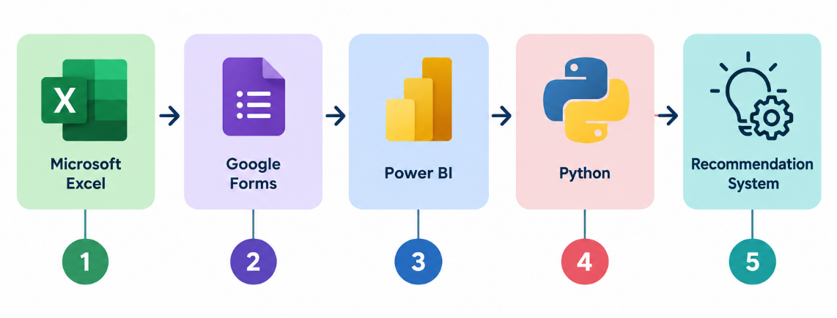
Figure 1: Tools & Technologies Used

CHAPTER 4: FIELD WORK DESCRIPTIONS, OBSERVATIONS AND ANALYSIS

4.1 Field work descriptions
The fieldwork for this project was carried out at N.R. Swamy College of Commerce and Economics. The activities focused on understanding how lecture slots and classrooms are planned and how they are actually used.
The team first collected the official timetable to understand the planned lecture slots, classrooms and schedules. Classroom visits were then conducted to observe actual usage, including student presence, classroom capacity, occupancy and classroom changes.
A structured student questionnaire was also distributed to collect feedback about lecture timings, classroom conditions, classroom changes and scheduling-related problems. Faculty interaction and feedback were considered wherever available to understand the issue from the teaching perspective.
The collected information was organized into a structured dataset and later used for data cleaning, analysis and visualization. These activities were directly connected to the project objective of comparing planned schedules with actual usage and user experience.

4.2 Observations
The project was designed to observe several important areas.

Observation 1 — Lecture Slot Performance
Attendance was compared across different lecture slots.
This helped identify whether certain timings consistently performed differently from others.

Finding:
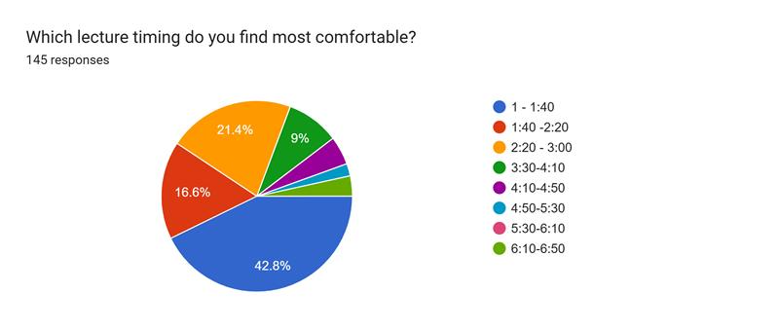Figure 2
Observation 2 — Classroom Utilization
Classroom capacity was compared with the number of students using the classroom.
This helped identify:
- Underutilized rooms
- Overcrowded rooms
- Better capacity matching opportunities
Observation 3 — Student Preferences
Student responses were analyzed to identify preferred and least-preferred lecture timings.
This provided a human perspective that timetable data alone could not provide.
Finding: 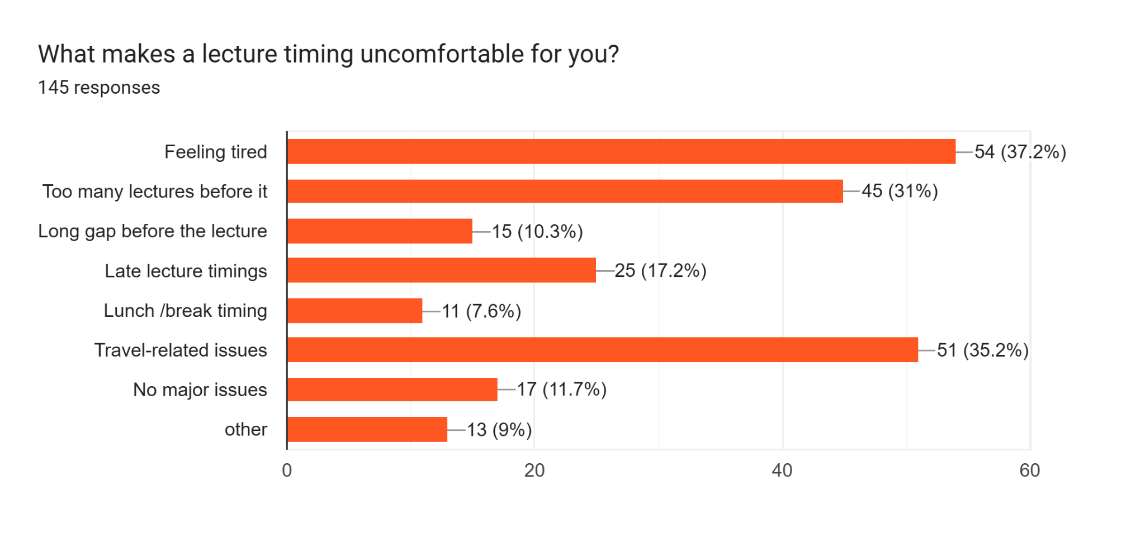Figure 3

Observation 4 — Classroom Changes
The survey and observation data were used to determine how frequently classroom changes occurred and whether they created problems.
Finding: 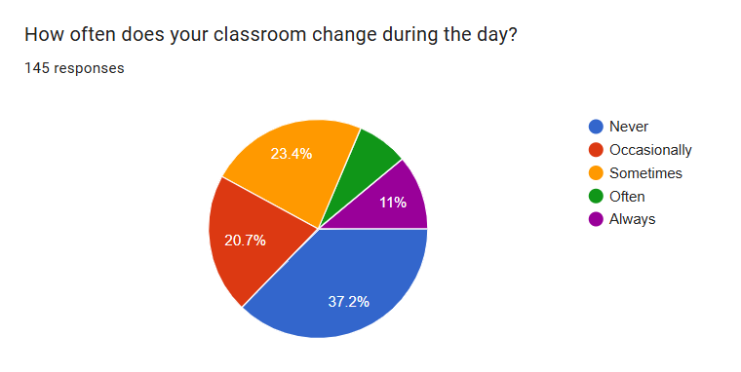Figure 4
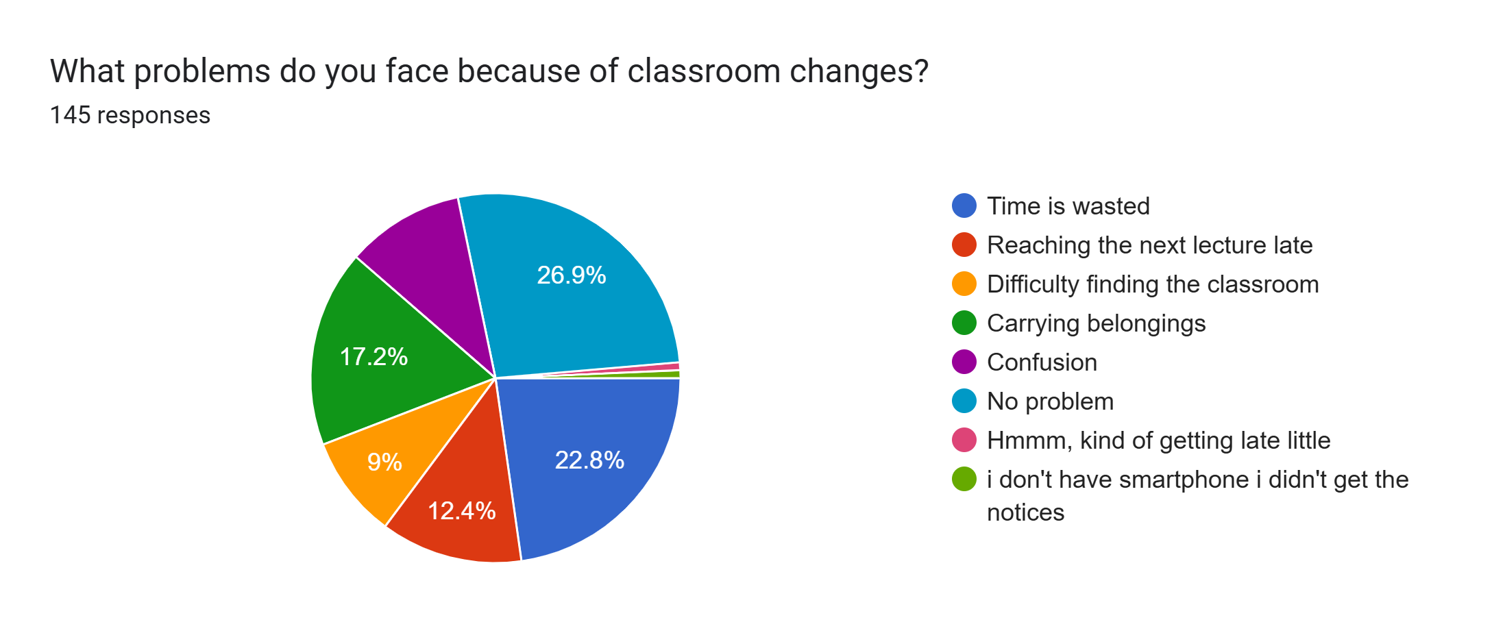Figure 5
Importantly, the project methodology allowed the data to determine whether classroom changes were actually a major issue rather than assuming that they were.

Observation 5 — Classroom Conditions
Student responses and classroom observations were used to study conditions such as:
- Seating
- Noise
- Lighting
- Fans
- AC
- Cleanliness
The purpose was to determine whether classroom conditions affected the lecture experience.
Finding: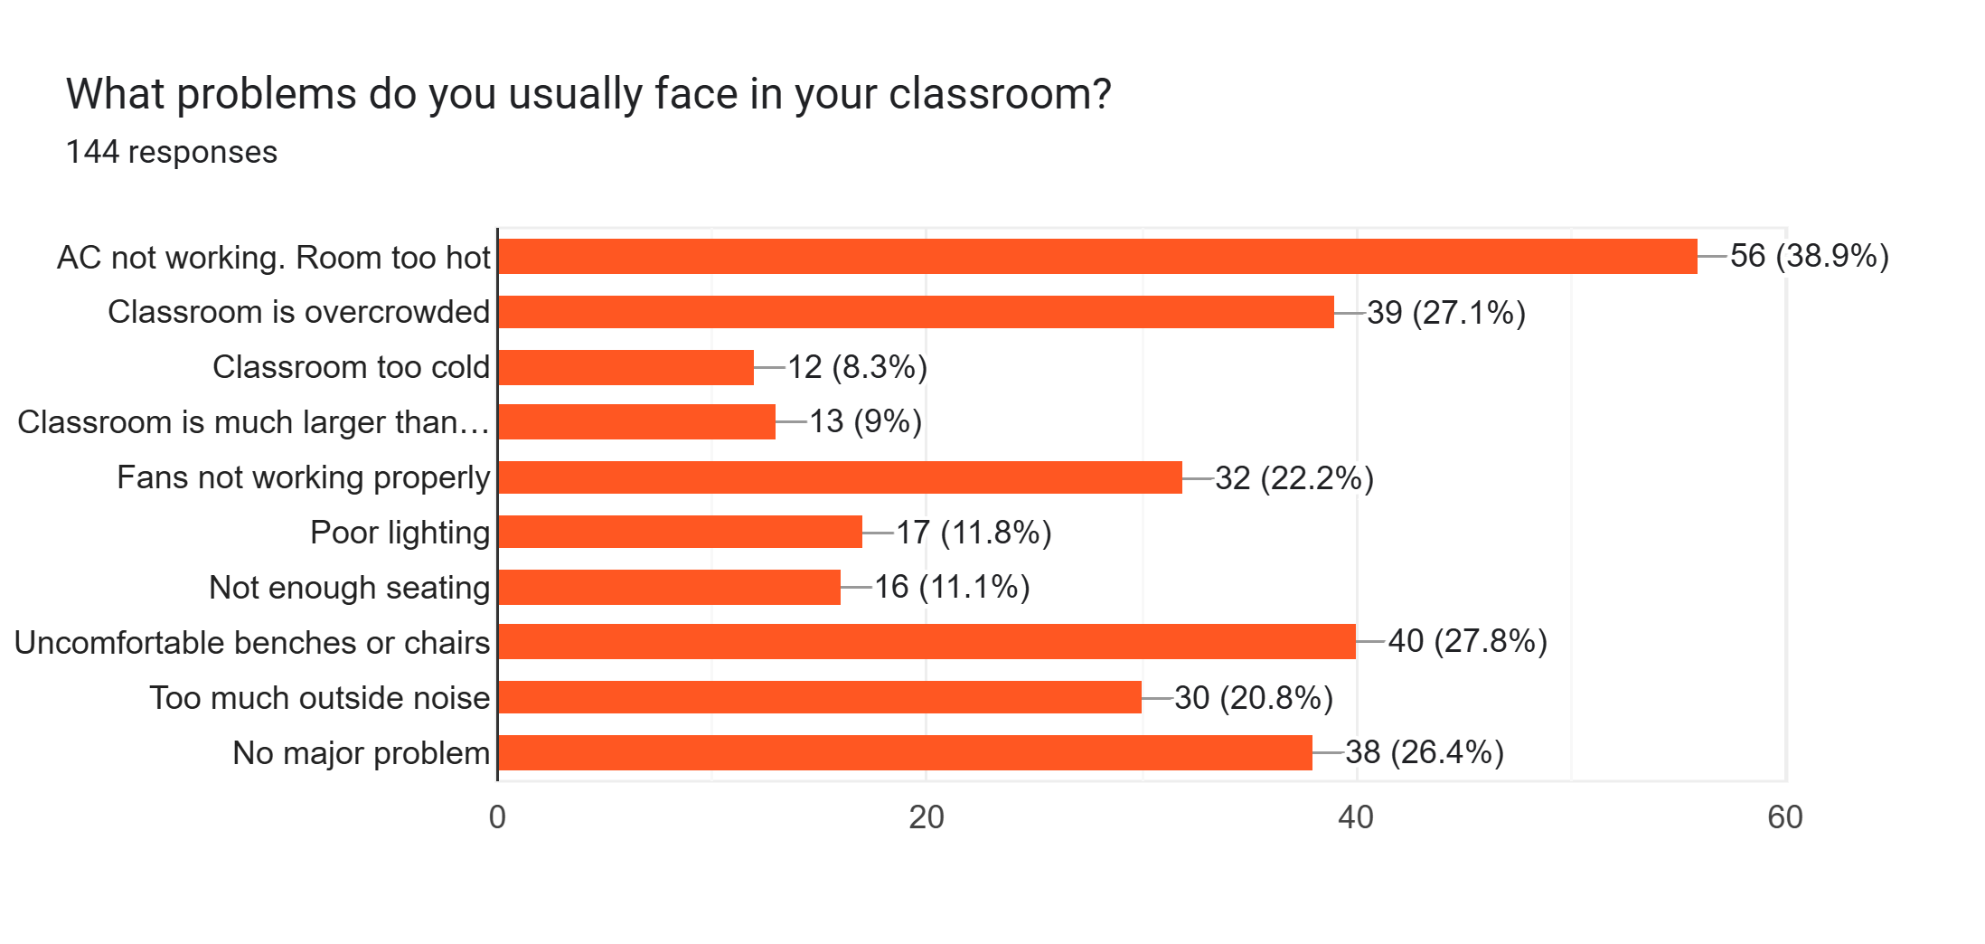Figure 6

4.3 Analysis

The responses show that students are more comfortable with the earlier lecture slots, especially 1:00–1:40 PM (42.8%). In comparison, the preference decreases for later timings. This indicates that lecture timing can affect student comfort, so timing preferences should be considered while evaluating the efficiency of different lecture slots. (Figure 2)
The responses show that feeling tired (37.2%) and travel-related issues (35.2%) are the major reasons students find lecture timings uncomfortable. A considerable number of students also mentioned having too many lectures before the particular lecture (31%). Late lecture timings were another concern for 17.2% of students. These responses show that students’ comfort with a lecture slot is influenced not only by the timing itself but also by their workload and travel time. This provides useful student-level insight for evaluating lecture slots and identifying timings that may need improvement. (Figure 3)
The responses show that classroom changes are fairly common, with 23.4% of students experiencing them sometimes and 11% always. Among the reported problems, time being wasted (22.8%) and reaching the next lecture late (12.4%) are notable concerns, while 17.2% mentioned the difficulty of carrying belongings. This shows that classroom changes can affect students’ time and movement between lectures, making classroom allocation an important factor in improving timetable efficiency. (Figure 4 & 5)
The main classroom issues reported were AC/room temperature (38.9%), uncomfortable seating (27.8%), and overcrowding (27.1%).
These conditions, along with poor ventilation, noise, and inadequate lighting, can negatively affect students’ comfort and concentration during lectures. (Figure 6)

CHAPTER 5: FIELD VISIT DETAILS
5.1 Field Visit Photographs
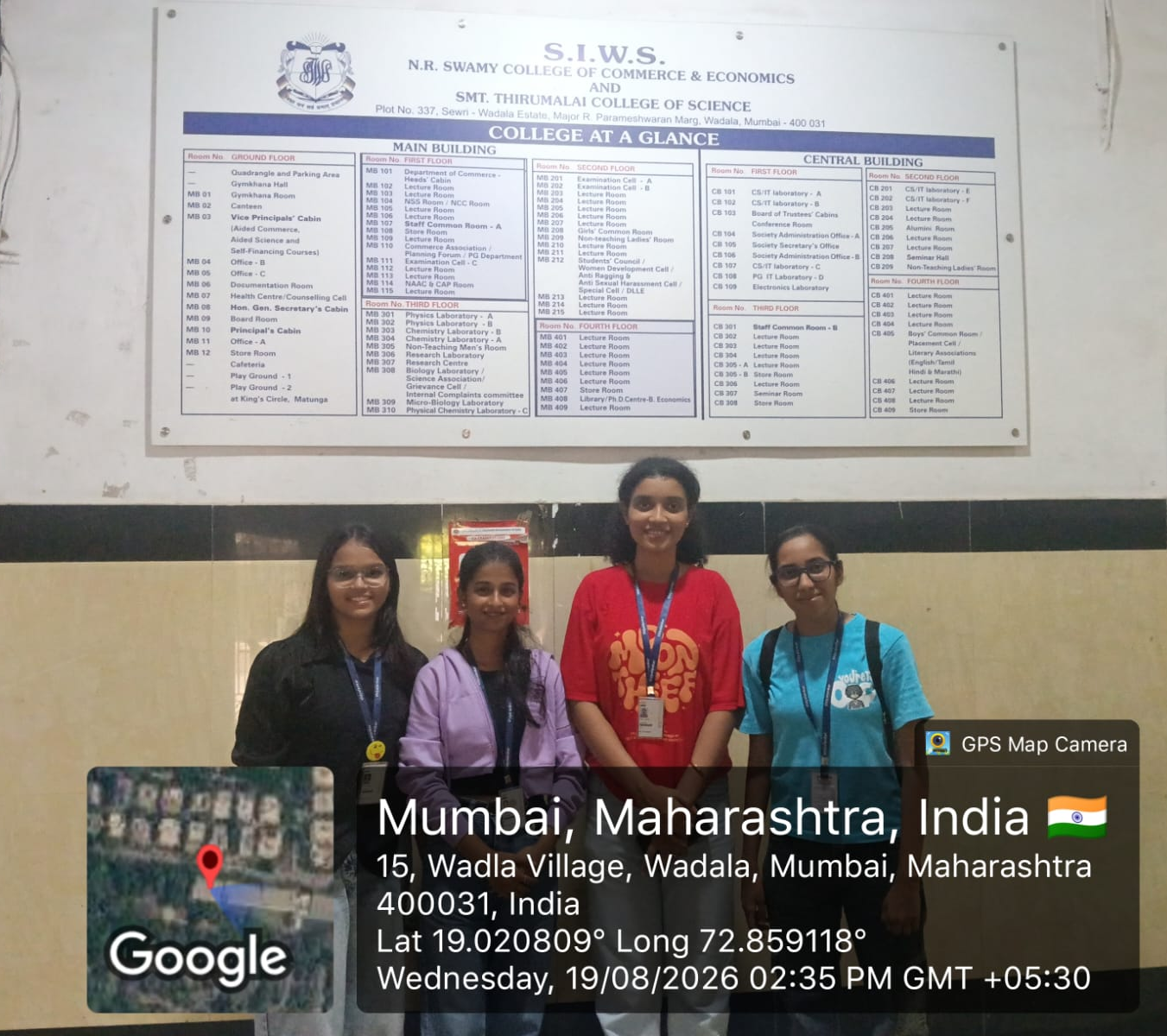
Figure 7: Team Photograph During the Field Visit
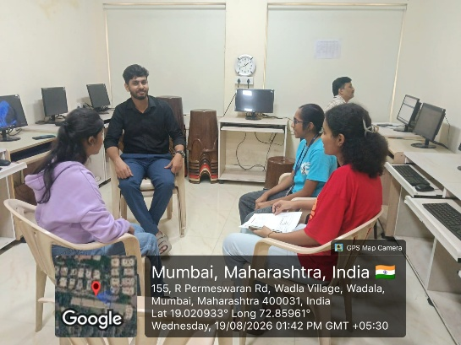
Figure 8: Interaction with the Contact Person During the Field Visit

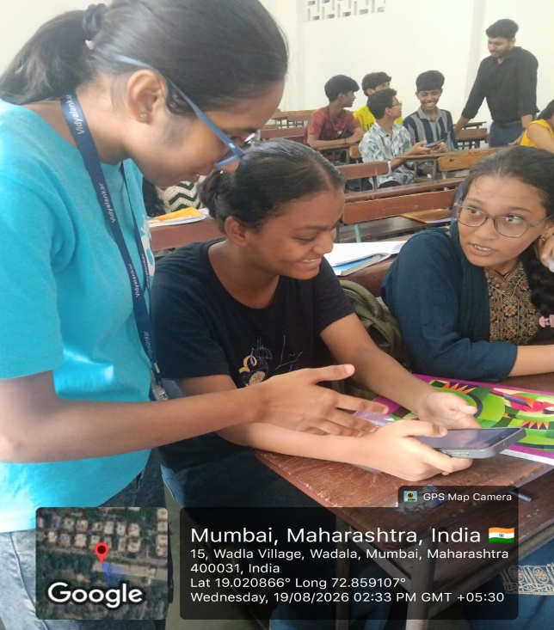

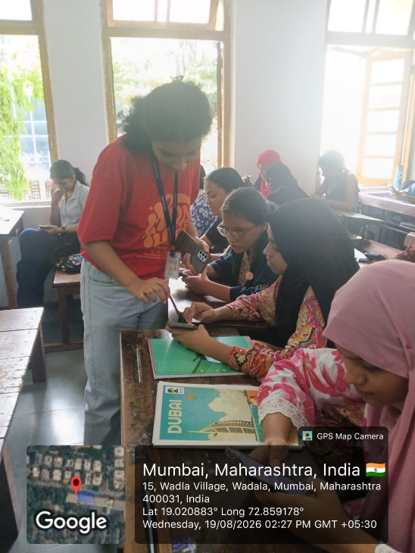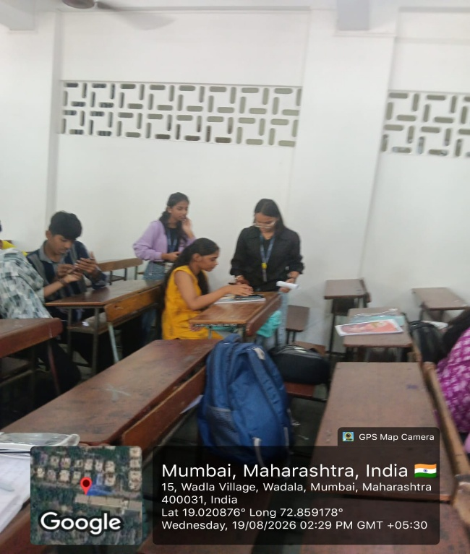
Figure 9,10,11: Team Helping Students Fill Out the Survey Form

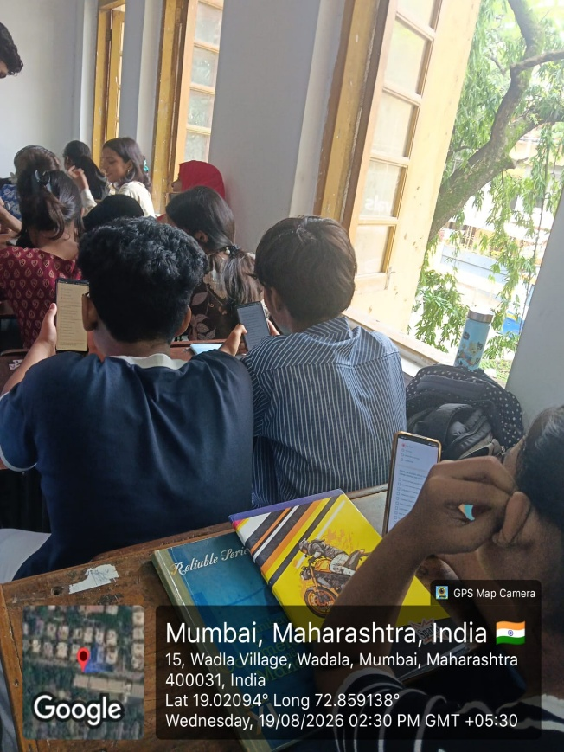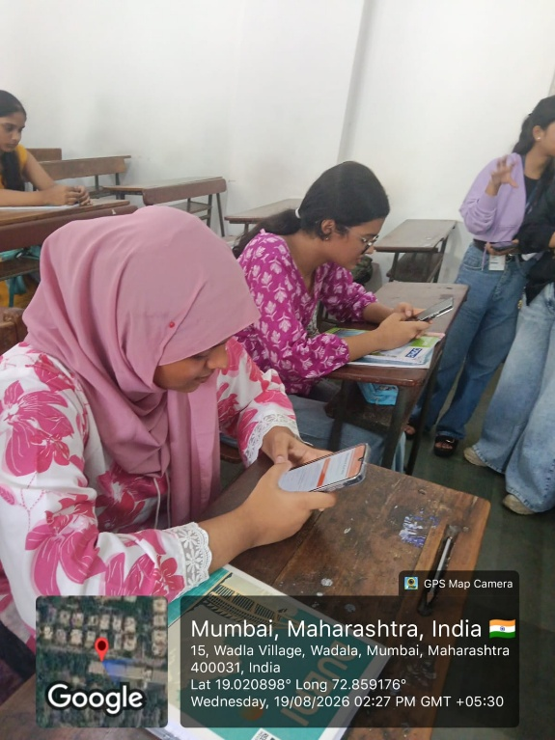
Figure 12,13: Students Filling Out the Survey Form

5.2 Evaluator Form Photographs
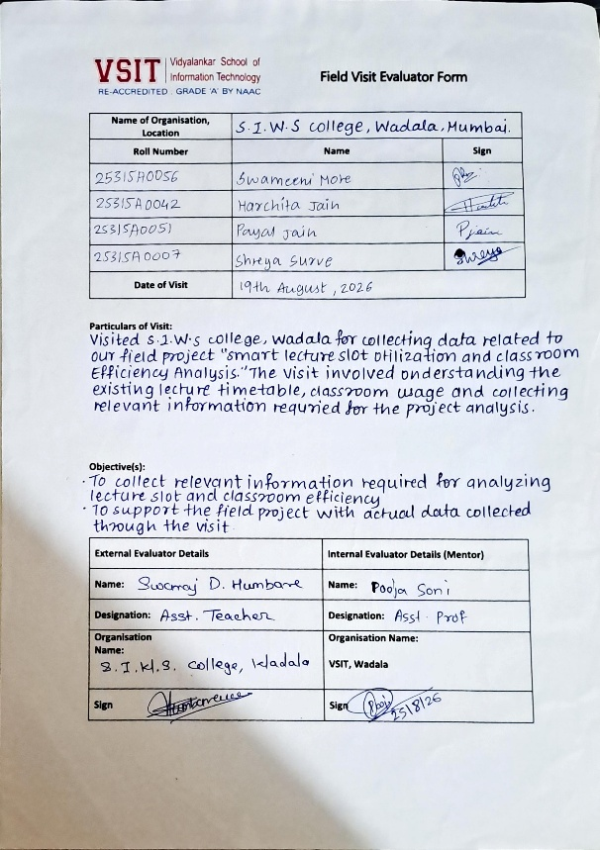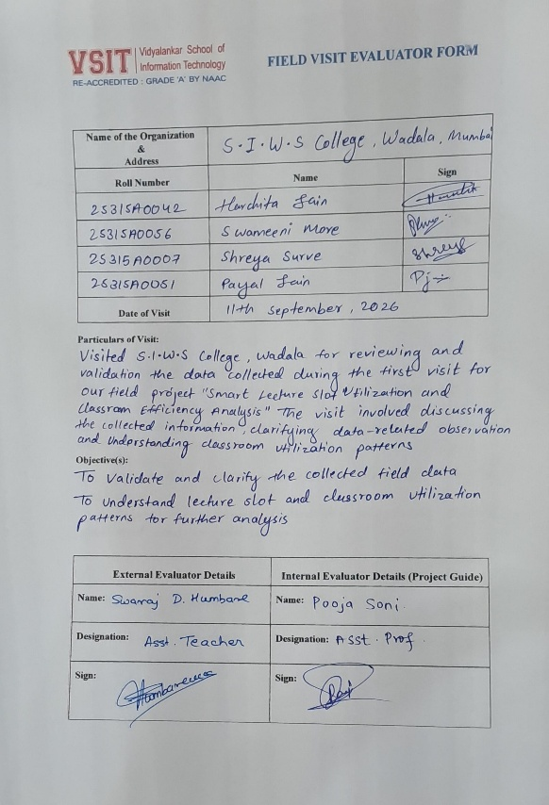
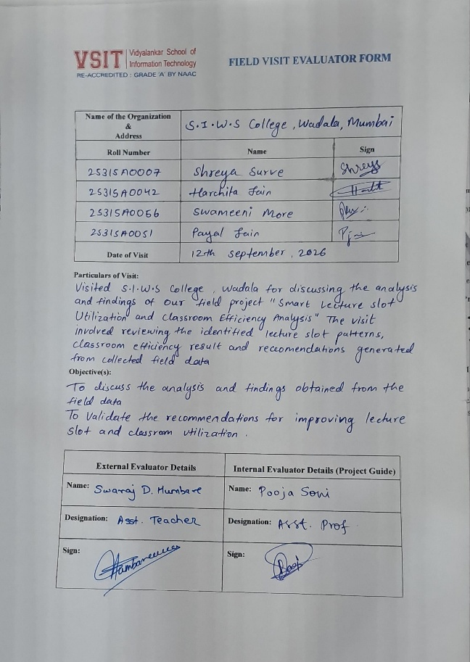

Figure 14,15,16: Field Visit Evaluator Form (1,2,3)

5.3 Guide Interaction Diary Photograph

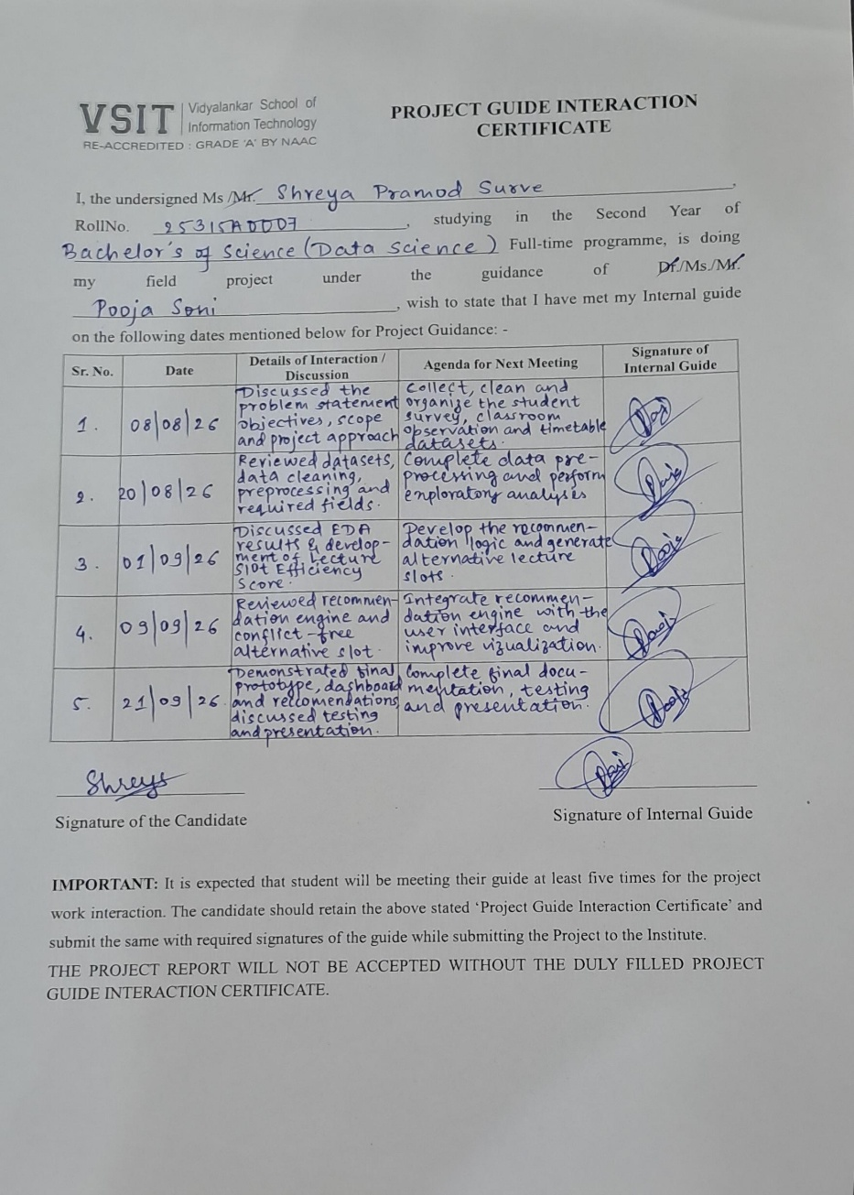

Figure 17: Guide Interaction Diary Form

CHAPTER 6: CONCLUSION AND RECOMMENDATIONS

6.1 Conclusion
The project provided a practical way to study lecture scheduling and classroom utilization using real data.
The project began with a simple question:
Is the existing timetable and classroom usage actually working efficiently?
The project studied lecture slot utilization and classroom efficiency using the official timetable, classroom observations, and student feedback. The survey showed that lecture timing, classroom changes, and classroom conditions can affect students’ comfort and learning experience.
The findings showed that 42.8% of students preferred the 1:00–1:40 lecture slot, while tiredness, multiple lectures before a class, and travel-related issues were commonly reported as reasons for uncomfortable timings. Classroom-related issues such as AC problems, uncomfortable seating, overcrowding, and outside noise were also reported by students.
Overall, the project helped identify patterns in lecture timings and classroom usage from actual data. These findings can be used to support better lecture scheduling, classroom allocation, and future improvements in classroom management.
Therefore, the project successfully followed a complete Data Science workflow:
Raw Data - Clean Data - Analysis - Visualization - Performance Measurement - Recommendation
The major learning from the project was that data analysis does not end with finding a pattern.

THE REAL VALUE COMES FROM USING THAT PATTERN TO SUPPORT A PRACTICAL DECISION.
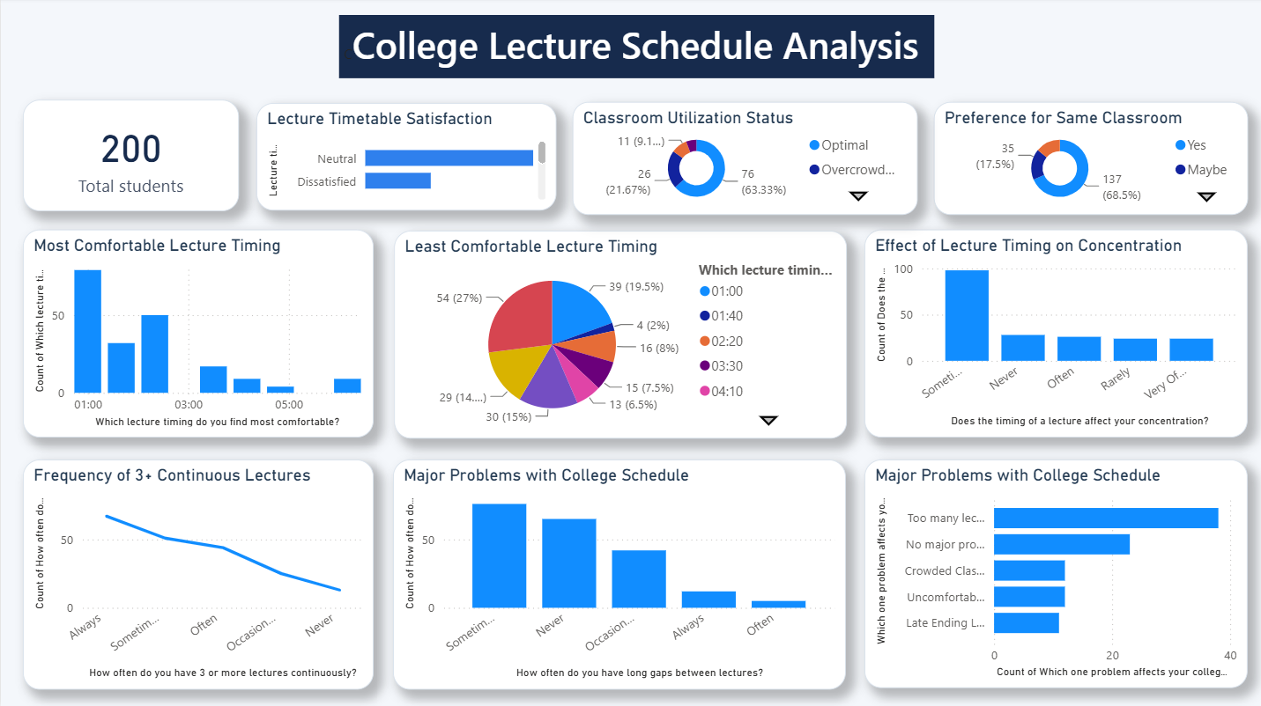
figure 18: Dashboard

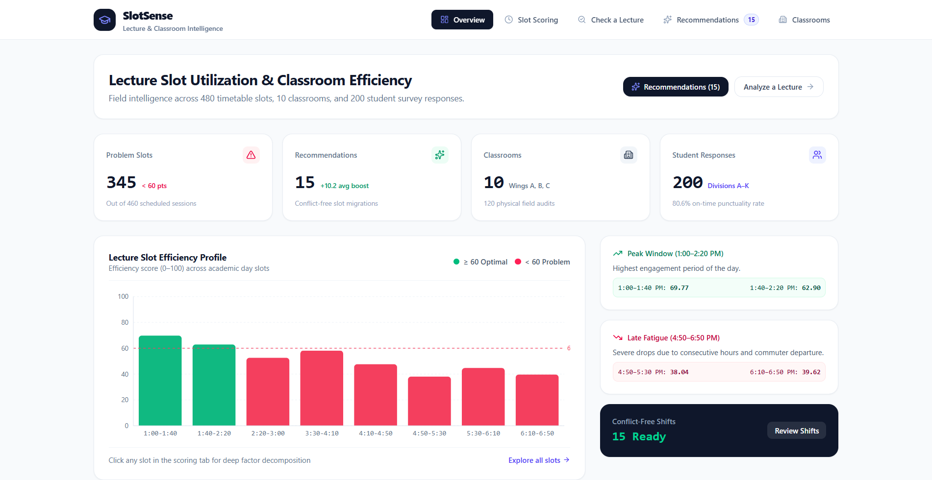

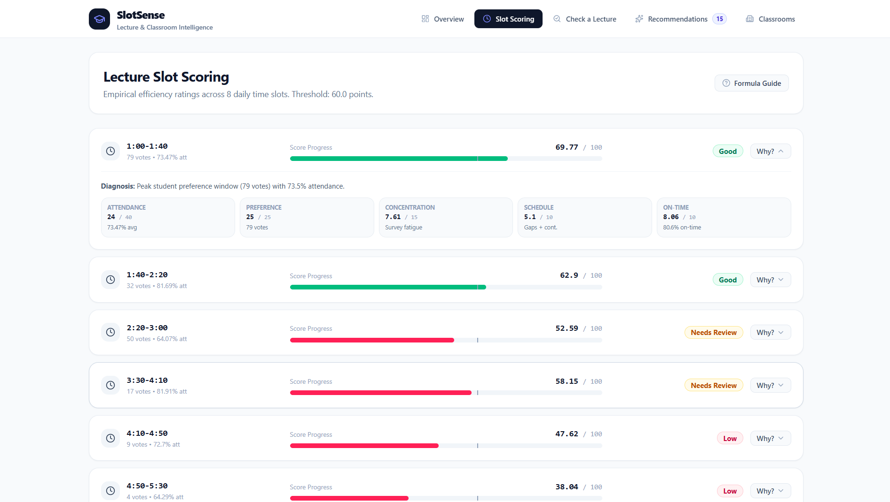

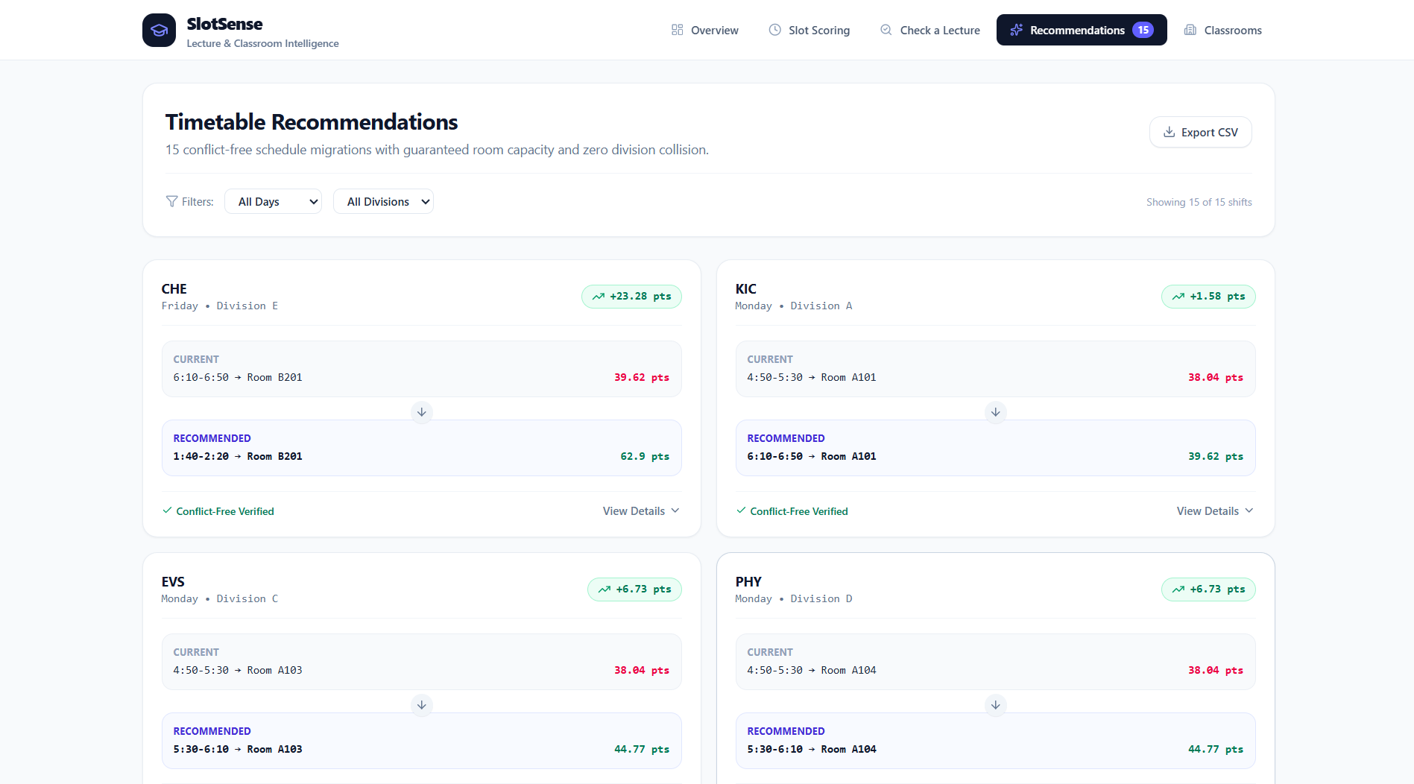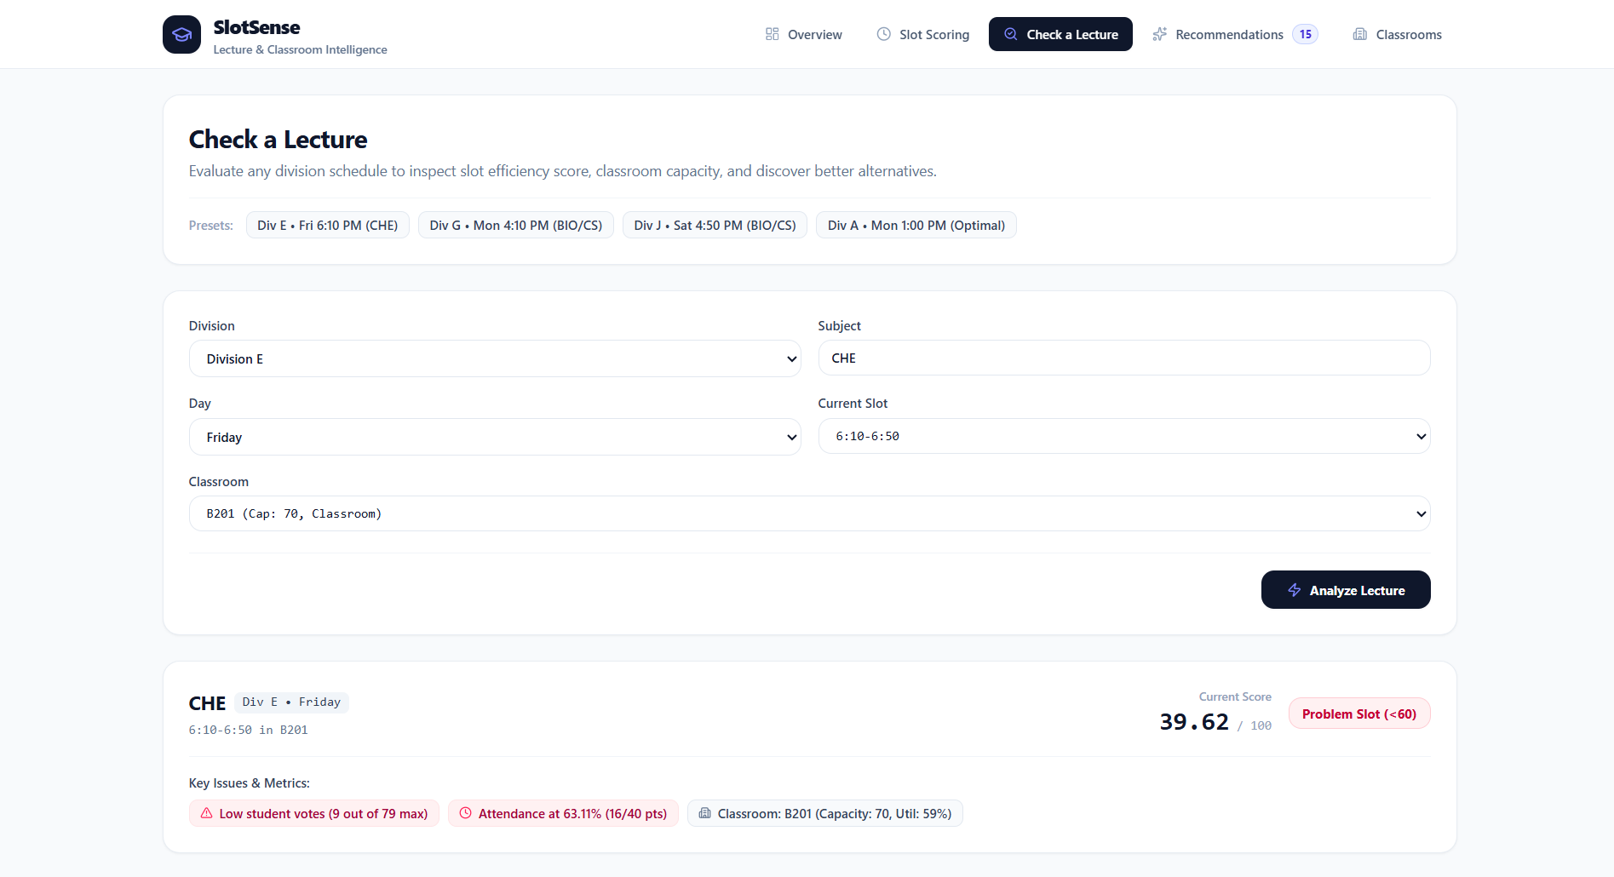

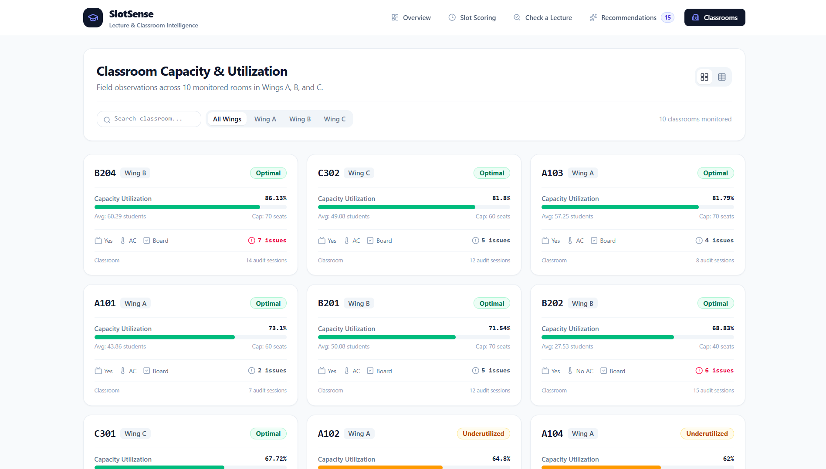

Figure 19,20,21,22,23: Recommendation System

6.2 Recommendations

Power BI Dashboard – Key Insights from Field Data (figure 18: Dashboard)
The Power BI dashboard was created to get a clear picture of how students experience the current lecture timetable and how efficiently the classrooms are being used. The dashboard combines the responses collected from 200 students with the classroom observation data collected during our field visits. Instead of looking at each response separately, the visuals helped us identify the main patterns and problem areas in the existing schedule.

1. Lecture Timetable Satisfaction
The dashboard shows that 100 out of 200 students were neutral about the current lecture timetable, while 39 students were dissatisfied and 12 were very dissatisfied. Only a smaller number of students were satisfied or very satisfied.
This shows that the current timetable is not necessarily viewed as completely unacceptable, but there is clear scope for improvement. A large neutral group also suggests that students may be managing with the existing timetable rather than finding it genuinely convenient.
This became one of the reasons for looking deeper into individual lecture timings instead of judging the entire timetable as simply good or bad.

2. Most and Least Comfortable Lecture Timings
A clear difference can be seen in students' timing preferences. 1:00–1:40 PM was the most preferred timing, with 79 students selecting it as their most comfortable slot. The next preferred timings were 2:20–3:00 PM and 1:40–2:20 PM.
On the other hand, 6:10–6:50 PM was the least comfortable timing for 54 students, making it the most noticeable late-day concern in the survey.
This is useful because it shows that student comfort changes depending on the time of the day. These preferences were later used in our recommendation system while calculating the efficiency score of each lecture slot.

3. Effect of Timing on Concentration
The dashboard also shows that lecture timing does have an effect on students' concentration. The largest group selected “Sometimes”, while other students reported that timing affects their concentration often, very often or rarely.
This tells us that timing is not only a matter of convenience. It can also influence how easily students are able to focus during a lecture.
Because of this, concentration was included as one of the factors in our Lecture Slot Efficiency Score rather than considering attendance alone.

4. Continuous Lectures
The dashboard shows that students frequently experience three or more lectures continuously. “Always” and “Sometimes” form the larger responses in this question.
This indicates that the problem is not limited to one particular lecture slot. The arrangement of lectures throughout the day can also affect students' overall experience.
Therefore, while analysing a slot, our system also considers the broader schedule burden caused by continuous lectures.

5. Long Gaps Between Lectures
The responses also show that long gaps between lectures are experienced by a considerable number of students. “Sometimes” is the most common response, followed by “Never” and “Occasionally”.
This gives us another important timetable-related issue. A timetable can have fewer continuous lectures but still be inconvenient if students have unnecessarily long gaps between classes.
Because of this, long gaps are also considered while calculating the schedule component of the slot score.

6. Classroom Utilization
The classroom observation data gives us a different type of insight. Out of the 120 classroom observations, 76 were marked as Optimal, while 26 were Overcrowded. There were also observations classified as underutilized or vacant.
This means that although a majority of the observed classroom usage was satisfactory, classroom utilization was not consistent everywhere.
Some classrooms were being used beyond their suitable capacity, while others were not being utilized to their full potential. This showed us that classroom allocation should also be considered when looking for timetable improvements.

7. Preference for the Same Classroom
A significant finding from the student survey was that 137 out of 200 students (68.5%) preferred having the same classroom for multiple lectures.
Another 35 students selected “Maybe”, while only a smaller group did not prefer the same classroom.
This suggests that frequent classroom changes can create inconvenience for students. It also supports the need to consider classroom availability and suitability when recommending a timetable change.

8. Major Problems with the Current Schedule
The dashboard also highlights the problems students experience most with the current schedule. Having too many lectures appears as the most prominent issue, followed by students who reported no major problem and other concerns such as crowded classrooms, uncomfortable timings and late-ending lectures.
This helped us understand that the timetable problem is not caused by one single factor. There are multiple factors affecting the student experience, which is why our project uses several parameters instead of relying on only one measure.

Overall Insight from the Dashboard
Overall, the dashboard helped us identify a few important patterns in the collected field data. Students showed a strong preference for earlier lecture timings, while the 6:10–6:50 PM slot was clearly less comfortable. Continuous lectures and long gaps were also common concerns. At the classroom level, most observations were optimal, but overcrowding and underutilization were still present. These findings helped us move from simply observing problems to measuring them. The insights from the dashboard were then used as inputs for our Lecture Slot Efficiency Score and Recommendation System, where the system checks whether a problematic lecture slot can be improved without creating conflicts in the timetable or classrooms.

Our Solution (Figure 19,20,21,22,23: Recommendation System)

SlotSense – Overview
The Overview page gives a quick picture of the current lecture timetable and classroom situation using data from 480 timetable slots, 10 classrooms and 200 student responses.
The main finding is that 345 out of 460 scheduled sessions scored below 60, showing that many sessions need further attention. The slot profile also shows that 1:00–1:40 PM (69.77) and 1:40–2:20 PM (62.90) perform better, while the later timings have noticeably lower scores. The dashboard also highlights 1:00–2:20 PM as the peak window and 4:50–6:50 PM as the late-fatigue period.
The 15 conflict-free recommendations show that the system is not only identifying problems but also finding possible improvements after checking timetable and classroom constraints.
Overall, this page gives us a quick understanding of where the main problems are and where the system can potentially improve the timetable.

Lecture Slot Scoring
The Lecture Slot Scoring tab helps us compare all lecture timings using a common score out of 100. The score is calculated using five factors: attendance, student preference, concentration, schedule burden and on-time performance.
A score of 60 or above is considered good, while slots below 60 are marked for further review. For example, 1:00–1:40 PM scores 69.77 because it has the highest student preference and good attendance. Similarly, 1:40–2:20 PM scores 62.90 and is also classified as good.
The scores decrease in the later slots. For example, 4:10–4:50 PM scores 47.62 and 4:50–5:30 PM scores 38.04, showing that these timings may need attention.
The main benefit of this tab is that it does not only give a final score. It also shows the contribution of each factor, helping us understand why a particular lecture slot is performing well or poorly. The low-scoring slots are then considered for further checking and possible recommendations.

Timetable Recommendations
The Recommendations tab shows the lecture slots that can be improved based on their efficiency scores. For each case, the system compares the current slot and classroom with a better alternative and also shows the improvement in score.
Before giving a recommendation, it checks that the division has no timetable clash and the suggested classroom has enough capacity. For example, the CHE lecture in Division E can be moved from 6:10–6:50 PM (39.62) to 1:40–2:20 PM (62.90), giving an improvement of 23.28 points.
Thus, this tab converts the identified problem into a practical, conflict-free timetable suggestion instead of simply pointing out that a slot is inefficient.

Check a Lecture
The Check a Lecture tab allows us to examine one particular lecture in detail instead of analysing the whole timetable at once. We can select the division, subject, day, current slot and classroom, and the system then gives its efficiency score.
For example, the selected CHE lecture in Division E has a score of 39.62, so it is identified as a problem slot. The system also shows the main reasons behind the low score, such as lower student preference and the attendance level. This helps us understand what is causing the problem in that particular lecture and provides a starting point for finding a better alternative.

Classroom Capacity & Utilization
The Classrooms tab helps us check whether the available classrooms are being used appropriately. It shows the capacity utilization of each monitored classroom along with the average number of students, classroom capacity and observed issues.
For example, classrooms such as B204, C302 and A103 are shown as optimally utilized, while A102 and A104 are marked as underutilized. This helps us identify classrooms that may have more space than required and classrooms where utilization needs attention.
The information is also useful when making timetable recommendations because the system can consider classroom capacity and availability before suggesting a change. This prevents a timetable improvement from creating a new classroom-related problem.

REFERENCES

Research Papers
- Babaei, Hamed, Jaber Karimpour, and Amin Hadidi. “A Survey of Approaches for University Course Timetabling Problem.” Computers & Industrial Engineering, vol. 86, 2015, pp. 43–59.
- Abdelhalim, Esraa A., and Ghada A. El Khayat. “A Utilization-Based Genetic Algorithm for Solving the University Timetabling Problem (UGA).” Alexandria Engineering Journal, vol. 55, no. 2, 2016, pp. 1395–1409.
- Muklason, Ahmad, Andrew J. Parkes, Ender Özcan, Barry McCollum, and Paul McMullan. “Fairness in Examination Timetabling: Student Preferences and Extended Formulations.” Applied Soft Computing, vol. 55, 2017, pp. 302–318.
- Ceschia, Sara, Luca Di Gaspero, and Andrea Schaerf. “Educational Timetabling: Problems, Benchmarks, and State-of-the-Art Results.” European Journal of Operational Research, vol. 308, no. 1, 2023, pp. 1–18.
- Mallari, Cristina Beatrice, Jayne Lois San Juan, and Richard Li. “The University Coursework Timetabling Problem: An Optimization Approach to Synchronizing Course Calendars.” Computers & Industrial Engineering, vol. 184, 2023, article 109561.

Websites / Tools Referred
- Microsoft. Microsoft Power BI. Microsoft Power BI
- Google. Google Forms. Google Forms

